**Objective:** At the end of this lab session students should be able to join tables and retrieve information.

**Table joining – part 2**

Section 1

You already know how join two or more tables when retrieving data in relational databases. Thus, in order for tables to be joined, there must be a foreign key relationship between them.

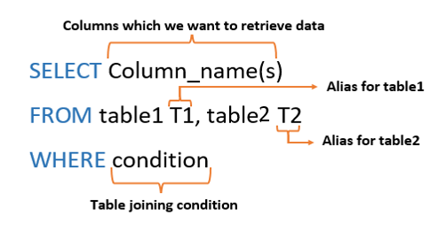

Figure 1: Table join syntax

Part a - Aliasing

Giving a temporary name (Alias) to a table or a column

Part b - Table joining condition

To join both tables the table joining condition should be written within the where clause always.

Section 2

Example

1. How many employees are there in each department, List the Department name and the no of Employees?

**Employee table**

|  |  |  |  |  |
| --- | --- | --- | --- | --- |
| **Ename** | **NIC** | **Eno** | **address** | **dnumber** |
| Smith,John B | 901250087V | 100 | 731 Fondren, Houston | 5 |
| Wrong, Franklin T. | 895290452V | 101 | 638 Voss, Houston | 5 |
| Zelaya, Alicia J. | 923859070V | 102 | 33321 Castle, Spring | 4 |

**Department table**

|  |  |
| --- | --- |
| **dno** | **dname** |
| 1 | Headquarters |
| 4 | Administration |
| 5 | Research |

# Step 01

We have to use both tables to get the required information and to get the number of employees in each department, COUNT function should be used.

**SELECT D.dname, COUNT (*) AS ‘No of employees’**

**FROM Employee E, Department D**

**WHERE E. dnumber = D. dno**

**GROUP BY D.dname,**

# Step 02

The resulting table is given in figure 2.

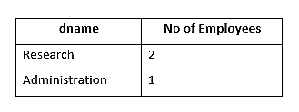

Figure 2: Output table

Exercise

1. How many Students are there in each course? List the CID and the number of students.
2. How many Students are there in each course? List the course name and the number of Students.
3. What are the courses which offer more than 2 modules for year 1 students?
4. What are the courses which offer more than 2 modules for any academic year? List the course names, academic year and the no of modules offered. Sort the result according to the no of modules.